Multimedia Critique Paper Two:
Flocabulary
Arthur Infantino
Coastal Carolina University

One of the objectives of education is for learners to remember information taught in a lesson. In the contemporary world, this aim is a challenging one; students have other distractions which hinder them from learning. Recently, one company has changed this paradigm by integrating rap and hip-hop music into music videos, which students have enjoyed. Flocabulary is an example of a multimedia website that is well-designed for instructors and students.
Flocabulary is a website that utilizes hip-hop and rap music videos to engage its audience from kindergarten to twelfth grade. (Vocabulary Words & Activities, 2017) This website was created by Blake Harrison and Alex Rappaport in 2004 when they were trying to help learners remember SAT vocabulary using music. (About Our Team, 2017) Today, Flocabulary has grown into eight hundred and thirty-six videos that include Language Arts, Math, Social Studies, Vocabulary, Science, and Life Skills. (Flocabulary- Educational Hip Hop, 2017) Flocabulary is not free- instructors can buy an individual license for ninety-six dollars, and district options which require a quote are also available. (Plans and Pricing, 2017)
What has made Flocabulary so engaging for learners and instructors? First, the instructor has two options initially, before showing the video to learners: the first choice is to slow the speed of the video if the learner cannot remember all the content in the video- this option is in upper right hand corner. (Image One) The other choice is utilizing the “pause and play” option in the bottom portion of Image One, which will stop the video and ask a question during the video. (Image Two) The instructor can then play the video from the paused point once the question is answered. (Image Two)
Therefore, Flocabulary touches upon a few multimedia principles introduced in these two features. First, the website is utilizing the segmenting principle, which means that learning is adjusted to the learner’s unique needs. (Mayer & Pilegard, 2014) Second, the spatial contiguity and temporal contiguity principles are applied- these principles indicate that text is close to images instead of far away, and text and images are presented at the same time and not on separate screens. (Reed, 2014) Finally, the coherence principle is employed because the website does not have unnecessary information on the screen when these features are utilized. (Reed, 2014)
Other options when viewing a video include quick review, lyric notes, read and respond; fill in the blanks, printable activity, quiz, and lyric lab. (Image Three) First, quick review has questions presented on the screen and the instructor controls when the answer is given to the students. (Image Four) Lyric Notes allows the instructor to play music with text on the screen which allows the learners to learn extra and relevant information on the topic at hand. (Image Five) Next, read and respond allows the learners to answer questions after reading text about the topic on hand. (Image Six)
The fill in the blank activity allows learners to fill in important words while listening to the videos and is available as a print copy. (Image Seven) The printable activity varies with each topic: in this case, the learner can construct their own meaning from the activities in the video, define words, and solve a graph activity. (Wir-march-3-2017-activity, 2017) The quiz reviews the content in the video using ten multiple choice questions on a video projection screen and is available in a print version. (Image Eight) Finally, the lyric lab allows learners to create their own learning by making their own rap song using beats and words from the topic. (Image Nine)
After reviewing these top options, printable activities, lesson plans and a teacher guide are also available for instructors on the bottom. (Image Three) First, the printable activities give print resources for instructors to utilize while teaching the content. (Image Ten) The lesson plans provide additional materials that could be helpful for teachers. (Image Eleven) Finally, the teacher guide explains the content, provides important words, and displays common core and state standards that are aligned to the content. (Image Twelve)
In review of the options available to learners, one would first note that quick review, lyric notes, read and respond; fill in the blanks, printable activity, and quiz are forms of behaviorism. (Ertmer & Newby, 1993) The learners are practicing what they know in simple comprehension activities, which should lead to better retention of the material overall. (Ertmer & Newby, 1993) However, the lyric lab is a great example of constructivism. (Ertmer & Newby, 1993) The learners are actively making meaning of the words and concepts presented in the video by creating their own song. (Image Nine) Therefore, Flocabulary allows for practice to remember the material and deeper level thinking skills to enhance memory recall of the topic.
Overall, Flocabulary is grounded in Baddeley’s Working Memory Theory and Paivio’s Dual Coding Theory. (Ertmer & Newby, 1993) First, Working Memory states that short term memory is enhanced when images and sounds are presented together. (Ertmer & Newby, 1993) Therefore, since the videos provide both images and music lyrics related to the content, Flocabulary is an effective instructional tool for learners to watch and instructors to utilize on a daily basis. Additionally, the text and images are shown at the same time, which supports the temporal contiguity principle. (Reed, 2006)
Next, Dual Coding Theory maintains that learners utilize text and image structures to make meaning of content in the long term memory. (Reed, 2006) Since the images are solid and real to the learner during the video, the learner should remember the content better. (Reed, 2006) Another important trait of the Dual Coding Theory is that material is relatable to the learner because most students enjoy the hip hop music along with the pictures in the videos. (Reed, 2006)
In terms of redesigning Flocabulary, the researcher believes the program would be more effective if the learners could obtain a reward from completion of activities. (Ertmer & Newby, 1993) Since the program is music based, perhaps the website could offer learners a choice of a song they would like to listen to after completion of one of the activities. On the other hand, Flocabulary is an effective tool for instructors and students without this minor change. The website boasts the results of its program on their own pages. (Raising Reading & Language Scores, 2017)
Flocabulary is a multimedia tool that can help learners and instructors make learning more meaningful for everyone involved. Adding music that is relatable to learners, and well animated videos makes this company one to watch in the future. Flocabulary provides instruction which should limit other diversions because music is a part of everyone’s lives. Creating unique ways to remember content can help instructors achieve the objective of their lessons.

Bibliography
About Our Team-Flocabulary. (2017). Retrieved from https://www.flocabulary.com/about/
Ertmer, P. A. & Newby, T.J. (1993). Behaviorism, cognitivism, constructivism: Comparing critical features from an instructional design perspective. Performance Improvement Quarterly, 6(4), 50-72. Doi: 10.1111/j.1937-8327.1993.tb00605.x
Flocabulary- Educational Hip-Hop. (2017). Retrieved from https://www.flocabulary.com/unit-overview/
Mayer, R.E. & Pilegard C. (2014) Principles for managing essential processing in multimedia learning: segmenting, pre-training, and modality principles. In R. E. Mayer (Ed.), The Cambridge Handbook of Multimedia Learning. (pp. 316-344). New York: Cambridge.
Plans and Pricing. (2017). Retrieved from https://www.flocabulary.com/plans/
Vocabulary Words & Activities- Vocabulary Rap Songs- Flocabulary. (2017). Retrieved from https://www.flocabulary.com/subjects/vocabulary/
Raising Reading & Language Arts Scores on State Tests- Flocabulary. (2017). Retrieved from https://www.flocabulary.com/results/
Reed, S. K. (2006). Cognitive architectures for multimedia learning. Educational Psychologist, 41(2), 87-98. Doi: 10.1207/s15326985ep4102_2
Wir-march-3-2017-activity [pdf file] (2017). Retrieved from https://s3.amazonaws.com/assets.flocabulary.com/pdfs/units/week-in-rap-march-3-2017-activities.pdf

Images
One
(from https://www.flocabulary.com/unit/week-in-rap-march-3-2017/video/)
Two
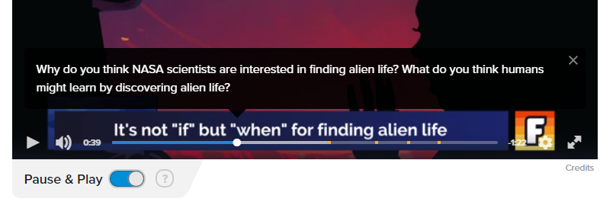
(from https://www.flocabulary.com/unit/week-in-rap-march-3-2017/video/)

Three
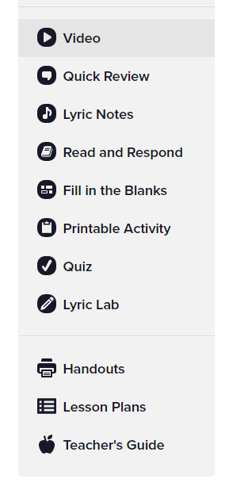
(from https://www.flocabulary.com/unit/week-in-rap-march-3-2017/video/)

Four
(from https://www.flocabulary.com/unit/week-in-rap-march-3-2017/quick-review/)

Five
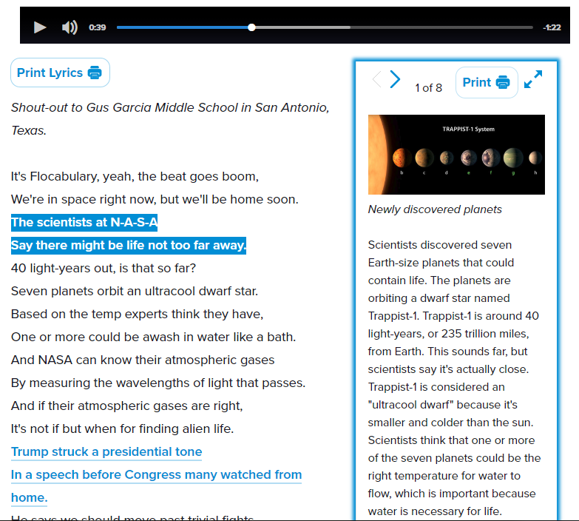
(from https://www.flocabulary.com/unit/week-in-rap-march-3-2017/lyric-notes/)

Six
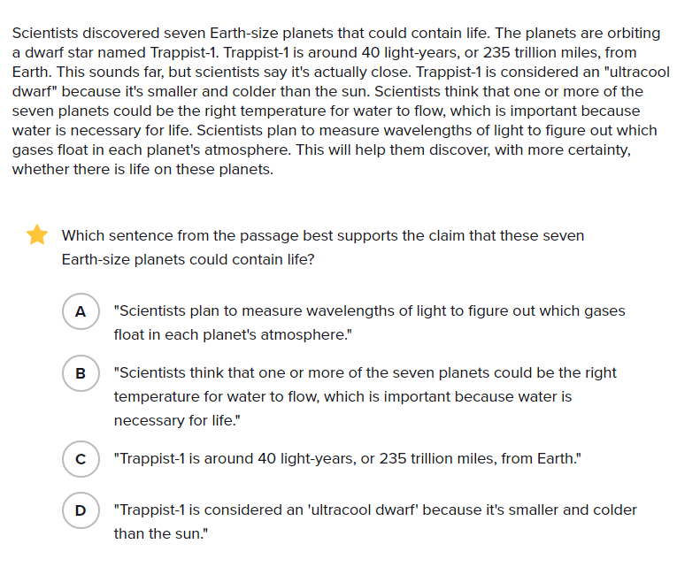
(from https://www.flocabulary.com/unit/week-in-rap-march-3-2017/read-and-respond/)

Seven
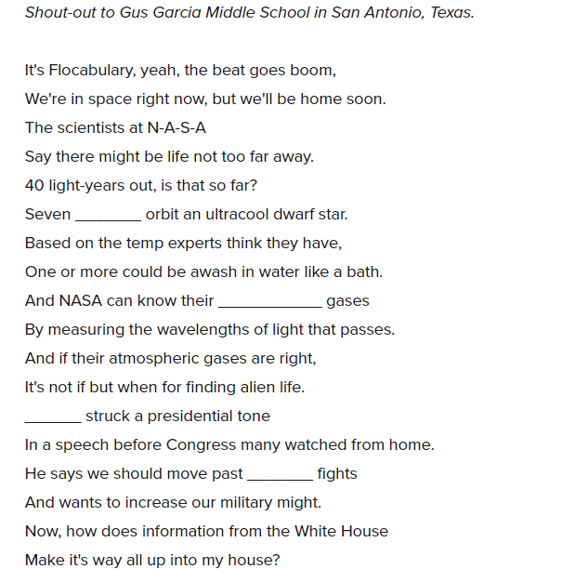
(from https://www.flocabulary.com/unit/week-in-rap-march-3-2017/fill-in-the-blanks/)

Eight
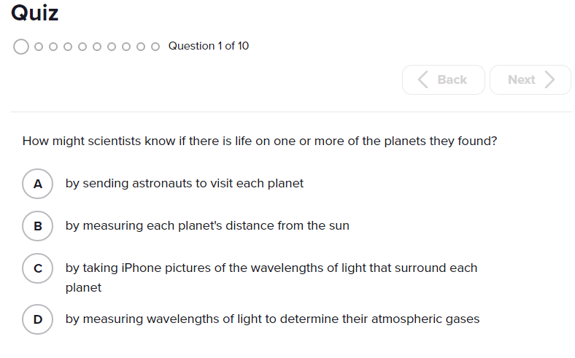
(from https://www.flocabulary.com/unit/week-in-rap-march-3-2017/quiz/)

Nine
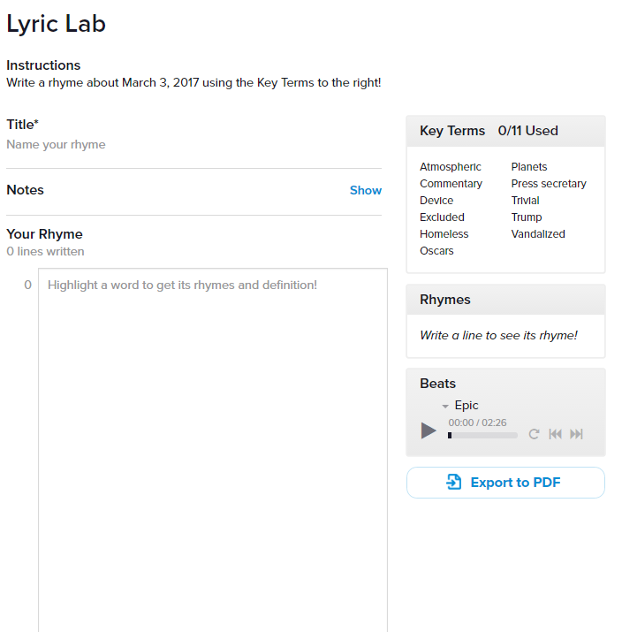
(from https://www.flocabulary.com/unit/week-in-rap-march-3-2017/lyric-lab/)

Ten
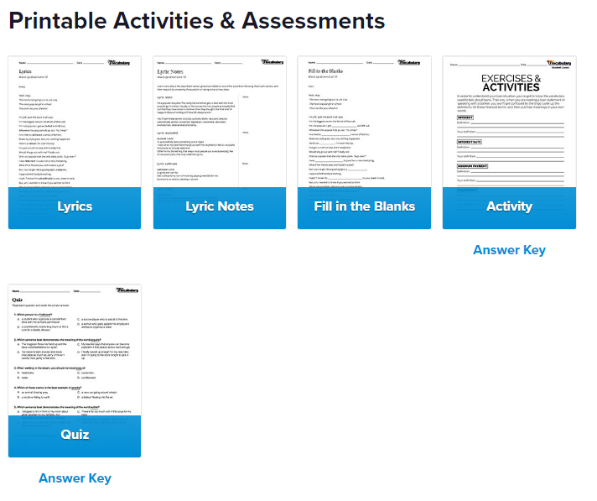
(from https://www.flocabulary.com/unit/week-in-rap-march-3-2017/handouts/)

Eleven
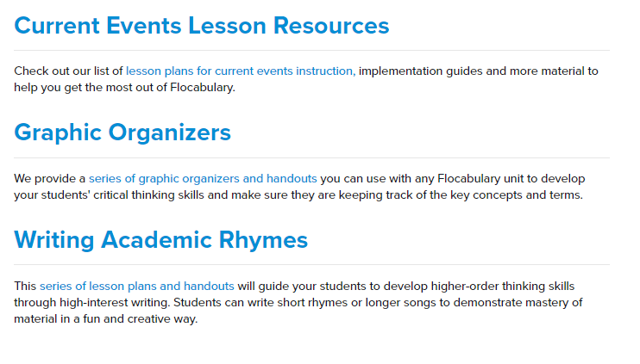
(from https://www.flocabulary.com/unit/week-in-rap-march-3-2017/lesson-plans/)

Twelve
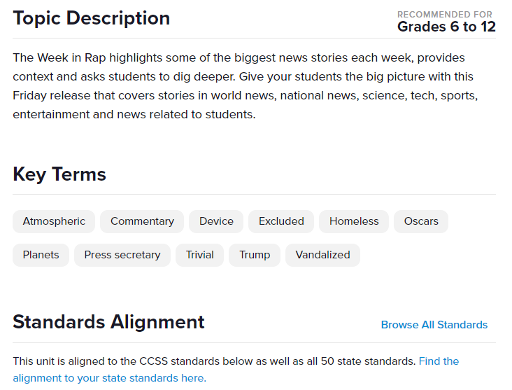
(from https://www.flocabulary.com/unit/week-in-rap-march-3-2017/teachers-guide/)

