Multimedia Critique Paper One:
Donkey Kong Junior Math
Arthur Infantino
Coastal Carolina University

Use of games in the classroom has been a common practice in educating students. Games can be either board-based, cards, or technology-based. However, technology games must be designed carefully for students because if the game has flaws, then the student will lose interest in that game. One game that had poor instructional design for learners was Nintendo’s Donkey Kong Junior Math.
This video game was a part of the initial launch of the Nintendo Entertainment System. (Kohler, 2010). The purpose of this game was to allow students to practice basic math skills in addition, subtraction, multiplication, and division. The audience intended for this game would be fourth grade level students and above. Donkey Kong Junior Math is available either on the Nintendo Entertainment System as a cartridge or online on a computer (http://www.retrogames.cz/play_196-NES.php?language=EN), and the Wii video game system online store (Thomas, 2007).
The gameplay of Donkey Kong Junior Math has three different modes: “Calculate A”, “Calculate B”, and “+-×÷ Exercise” (Image One). In “Calculate” mode, Donkey Kong Junior is given a number from Donkey Kong on the top of the screen and must calculate to the exact number Donkey Kong is holding while competing against another player (Image Two). Donkey Kong Junior can calculate the number by selecting a number on the vine and using addition, subtraction, multiplication, or division on the islands along with another number to get an answer (Image Two).
The numbers and operations of each player are in the top corners of the screen (Image Two). When Donkey Kong Junior gets the answer, he obtains a “win” (Image Two). After five wins, celebratory music is played, and the player is sent to the title screen (Image One). The difference between “A” and “B” modes is that the “A” mode focuses on positive numbers with two digits while the “B” mode has three digit positive and negative numbers.
The other mode of gameplay is the “+-×÷ Exercise”. When selected from the Title Screen (Image One), the player is sent to a place where the player can select multiplication, division, addition, and subtraction operations with various digits (Image Three). Next, the player is given a problem on the upper right hand corner of the screen (Image Four). If the player does not know how to solve the problem, he must climb up the chain with the question mark to get the answer (Image Four).
If the player knows the answer, he must climb up the chain where the purple bird is and climb up (high number is nine) or down (low number is zero) the chain to solve the problem (Image Four). The player fills in the digits, and after providing a solution, the computer tells the player if he is right or wrong. If the player is right the first time, the player receives points and a fruit next to the number on the bottom left part of the screen (Image Four).
If the player is wrong, the player is allowed to correct the problem and obtain some points but will not receive a fruit next to a number. If the player continues to be wrong on that problem, he will lose the chance to receive points. After ten problems are completed, regardless of the number of fruits or number of points scored, celebratory music is played, and the player is sent back to the title screen.
The researcher played this game on his computer and noted many different flaws. First, in the “Calculate” mode, the pink monkey will not move because the other character needs to be controlled by another human player. Therefore, the competition aspect of the game is diminished greatly because without another player, the single player can solve the problem easily. Second, in the “+-×÷ Exercise”, if the player accidentally fills in the wrong digit, the player cannot correct the problem until the computer checks the answer. Third, no matter how many correct solutions or points, the player reward is music and being sent back to the title screen.
Donkey Kong Junior Math shows an early example of behaviorism, which believes that learners should practice basic skills such as addition, subtraction, multiplication, and division until the tasks is, understood (Ertmer & Newby, 1993). Therefore, another deficiency of this game is that higher level math skills cannot be practiced as illustrated in other learning theories such as cognitivism and constructivism. According to Egenfeldt-Nielsen (2007), Donkey Kong Junior Math is considered “Edutainment…which covers the combination of educational and entertainment use on a variety of media platforms….” (p. 264) Other problems noted in edutainment include utilizing points and objects as rewards, easy practice and gameplay, no teachers to assist in playing the game, and minor costs in production (Egenfeldt-Nielsen, 2007). Due to the Nintendo Entertainment System initial entry in the United States in the mid-1980s, this game did not receive the attention necessary to be successful (Donovan, 2010).
In terms of multimedia principles, Donkey Kong Junior Math achieves two multimedia principles well and other principles poorly according to the Mayer research (Reed, 2006). On the positive side, the game demonstrates the coherence principle because it does focus on the math skills needed to solve the problems as seen in Image Two and Four (Reed, 2006). In the“+-×÷ Exercise”, the temporal contiguity principle is achieved because all the numbers and operations are available on the screen as seen in Image Four (Reed, 2006). Unfortunately, the game does violate the multimedia principle because besides the numbers and characters in the game, Donkey Kong Junior Math does not have pictures to assist learners in learning how to solve the math problems (Reed, 2006). Furthermore, the game does not have the modality principle, which states learners “…learn better from animation and narration than from animation and on-screen text.” (Reed, 2006, p.91)
Due to these shortcomings in Donkey Kong Junior Math, this game needs a thorough redesign. First, the game should have a mode that reviews math facts with the learners. This review will help the learner be able to accomplish tasks in either the “Calculate” or “+-×÷ Exercise”. This mode should have moving pictures and commentary as stated in Mayer’s modality principle (Reed, 2006). Second, in “+-×÷ Exercise”, the chains should be divided in numbers zero to nine to limit confusion in trying to obtain the right answer in that mode, or have tighter controls (Thomas, 2007). Also, the player should have the means to go back and change his answer to limit frustration if the player notices the wrong digit answer was input.
Additionally, in the “Calculate” mode, the player should be able to select between a computer or human mode before playing to offer competition in answering the questions. In order to enhance higher thinking skills, learners should have other modes than the ones listed in Image One. The game should have operations with fractions, exponents, equations, and other higher level numerical operational skills to practice. Finally, an incentive should be achieved after completing one of the modes that the player can choose if that player reaches that criterion. As Thomas (2007) and other reviewers stated, the game becomes uninteresting very quickly.
Donkey Kong Junior Math had great potential to be an excellent educational video game, but due to poor instructional design, it was not. Teachers and students can learn from Donkey Kong Junior Math that deficiencies can affect how a student perceives the product and its playability. Whatever the medium of the game is, a comprehensive review is needed before it is given to students. Gaming can have a positive impact in education as long as value is determined before implementation.
Bibliography
Donovan, T. (2010) Replay: The history of video games [Kindle version]. Hove, East Sussex (United Kingdom): Yellow Ant. Retrieved from Amazon.com.
Egenfeldt-Nielsen, S. (2007). Third generation educational use of computer games. Journal of Educational Multimedia and Hypermedia, 16(3), 263-281. Retrieved from https://www.learntechlib.org/j/JEMH
Ertmer, P. A. & Newby, T.J. (1993). Behaviorism, cognitivism, constructivism: Comparing critical features from an instructional design perspective. Performance Improvement Quarterly, 6(4), 50-72. Doi: 10.1111/j.1937-8327.1993.tb00605.x
Kohler, C. (2010, October 18). October 18th, 1985: Nintendo entertainment system launches. Wired. Retrieved from https://www.wired.com/2010/10/1018nintendo-nes-launches/
Reed, S. K. (2006). Cognitive architectures for multimedia learning. Educational Psychologist, 41(2), 87-98. Doi: 10.1207/s15326985ep4102_2
Thomas, L. M. (2007, September 6). Donkey Kong Junior Math Review. IGN. Retrieved from http://www.ign.com/articles/2007/09/07/donkey-kong-jr-math-review

Gameplay (Need Adobe Flash and Google Chrome)
http://www.retrogames.cz/play_196-NES.php?language=EN

Images
One
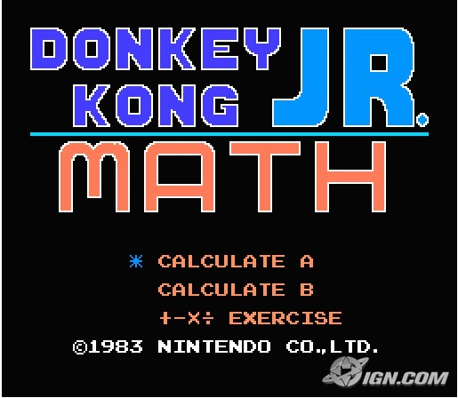
(from http://www.ign.com/images/games/donkey-kong-jr-math-wii-901970/4fa6ca5ccdc388ed13efabcf)

Two
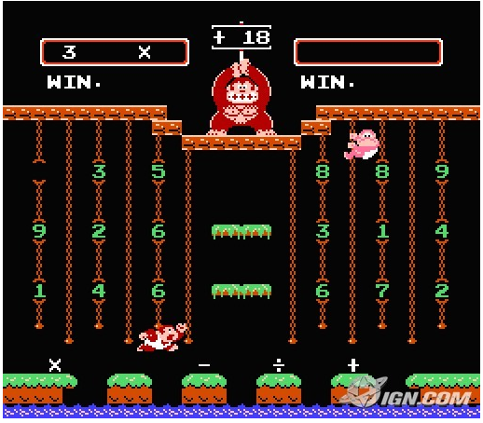
(from http://www.ign.com/images/games/donkey-kong-jr-math-wii-901970/4fa6ca5ccdc388ed13efabce)

Three
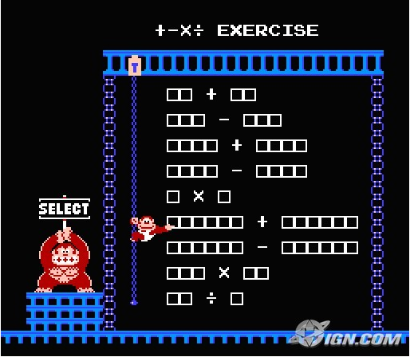
(from http://www.ign.com/images/games/donkey-kong-jr-math-wii-901970/4fa6ca5ccdc388ed13efabcd)

Four
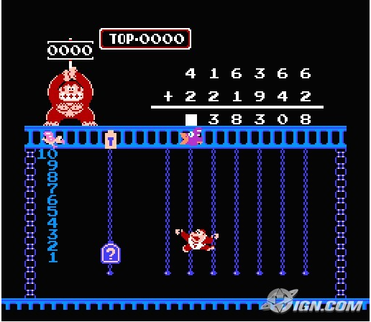
(from http://www.ign.com/images/games/donkey-kong-jr-math-wii-901970/4fa6ca5ccdc388ed13efabcf)

