Multimedia Critique Paper Three:
BrainPOP
Arthur Infantino
Coastal Carolina University

When an instructional designer creates a new lesson, he must consider a number of factors, including age of the learners. This element is critical because learning should match what the learner understands at his/her present age. Many multimedia tools are designed for learning for particular age groups so the content can be effective for the learners. BrainPOP is an effective multimedia website that provides many resources for instructors to utilize with specific age learners.
BrainPOP is a website that is designed specifically for grades four to eight. (About BrainPOP, 2017) The website was created by Doctor Avraham Kadar in 1999 “…as a creative way to explain difficult concepts to young patients.” (About BrainPOP, 2017) Today, the website now boasts content in Health, Math, English, Social Studies, and Science. (Our Company- About BrainPOP, 2017) Furthermore, the website has expanded from videos to include games, making maps, primary sources, challenges, and assignments. (Our Company- About BrainPOP, 2017) BrainPOP offers some free videos and content to anyone on its home page, but full access will incur a cost for instructors that use the website at home, in the school setting or virtual setting. (Subscribe, 2017)
What qualities does a BrainPOP video have for learners? First, the video provides text at the bottom of the screen for learners to follow along with, which can be switched on and off with the video as well as the ability to make the video full screen. (Image One) The instructor can manually stop the video to make a point to the students. (Image One) Unfortunately, the videos do not have questions inserted to stop the video to discuss an important point, meaning that the instructor will need to plan ahead in order to stop videos to start conversation with the learners.
While the learner or instructor does have control to stop or move the video at any time, this idea fits into the segmenting principle, which allows instructors and learners to view videos at their pace. (Mayer & Pilegard, 2014) Additionally, the videos do follow the spatial contiguity and temporal contiguity principles, which means that text is close to images instead of far away, and text and images are presented at the same time and not on separate screens. (Mayer & Pilegard, 2014) Overall, the videos do follow the coherence principle, which means unnecessary information does not interfere with the learning aspect at the beginning or the end of videos. (Reed, 2006) Finally in terms of videos, the modality principle is in effect since images and sounds are presented in the video. (Reed, 2006)
Additionally, the videos fit into the theories of Baddeley’s Working Memory and Paivio’s Dual Coding Theory. (Reed, 2006) Baddeley maintains that short term memory is aided by presenting images and sounds at the same time. (Reed, 2006) Therefore, since the videos have sound and images presented at the same time, it is an effective use of the limited capacity of short term memory. (Reed, 2006) Topics are presented in small amounts of information that help the learner remember what was witnessed in the video. (Reed, 2006)
Also, Dual Coding Theory states that learners utilize text and image arrangements to make meaning of content in the long term memory. (Reed, 2006) Since the images are well animated and “real” to the learner during the video, the learner should remember the content better. (Reed, 2006) Another important trait of the Dual Coding Theory is that the material is relatable to the learner because most students enjoy the adventures of Tim and Moby through the various subjects they discover. (Reed, 2006) The videos are well grounded in concepts of cognitive science.
Beside the videos, the website offers quizzes, games, challenges, make-a-map, FYI, and activities. (Image Three) The quizzes can be done by print or electronically, either by graded or review features- the graded feature does not tell the learner if they made a mistake, while the review feature will not move to the next question until it is answered correctly. The quiz part of BrainPOP is good for learners because it focuses on the concept of behaviorism- especially in the review part- meaning that the learner must figure out the answer before moving on to the next question. (Ertmer & Newby, 1993) Practice with questions such as the ones in in the quiz will help learners gain knowledge from the video.
In games, learners can organize elements in the correct order or group, or use hints to solve a problem situation. (Image Four) Games vary from topic to topic in the website- some games allow the user to explore an environment to solve a problem situation. (GameUp- BrainPOP, 2017) Therefore, the game portion of the website is good for learners because the game allows for constructivism, as the learner has to actively interact with elements in order to win the game. (Ertmer & Newby, 1993) Engaging in playful situations help learners remember concepts more clearly.
The make-a-map feature allows learners to make concept maps of the topic they just learned. (Image Five) The challenge presents concepts in higher level thinking skills such as underlining important points, putting concepts in the right order, and comparing and contrasting. (Image Six) Thus, the make-a-map and challenge of the website is good for the learners because these sections allow for cognitivism and constructivism since the learner has to make meaning of material utilizing higher level thinking utilizing schemas to solve a task. (Ertmer & Newby, 1993) Permitting learners to utilize more skills where they must do more than provide the correct response can help learners remember concepts more clearly in the future.
Finally, the FYI section of BrainPOP gives important and relevant details to the content the learner has discovered in the video. (Image Seven) The activities section allows learners to participate with interactive or print activities that include a graphic organizer or vocabulary. (Image Eight) Again, these features allow for more exploration- which involves behaviorism and constructivism- since the learner is actively engaged in the learning process and has to get the right answer before moving to the next task. (Ertmer & Newby, 1993) To restate, high level thinking tasks help learners to acquire long term knowledge for future tasks.
BrainPOP allows elementary and middle school students to succeed since it has proven to help them remember material. (Research Resources- BrainPOP, 2017) Instructional designers must take age into consideration to create effective tools for learners to succeed. Learning should correspond to the learner’s age and interests. Of all the factors in designing instruction, age should be near the top of the list to meet the needs of all learners.

Bibliography
About BrainPOP. (2017). Retrieved from https://about.brainpop.com
Civil War- BrainPOP. (2017). Retrieved from https://www.brainpop.com/socialstudies/ushistory/civilwar/
Civil War Quiz- BrainPOP. (2017) Retrieved from https://www.brainpop.com/socialstudies/ushistory/civilwar/quiz/
Ertmer, P. A. & Newby, T.J. (1993). Behaviorism, cognitivism, constructivism: Comparing critical features from an instructional design perspective. Performance Improvement Quarterly, 6(4), 50-72. Doi: 10.1111/j.1937-8327.1993.tb00605.x
GameUp- BrainPOP. (2017) Retrieved from https://www.brainpop.com/games/
Mayer, R.E. & Pilegard C. (2014) Principles for managing essential processing in multimedia learning: segmenting, pre-training, and modality principles. In R. E. Mayer (Ed.), The Cambridge Handbook of Multimedia Learning. (pp. 316-344). New York: Cambridge.
Our Company- About BrainPOP. (2017). Retrieved from https://about.brainpop.com/our-company/
Research Resources- BrainPOP. (2017) Retrieved from https://educators.brainpop.com/funding/research-resources/
Reed, S. K. (2006). Cognitive architectures for multimedia learning. Educational Psychologist, 41(2), 87-98. Doi: 10.1207/s15326985ep4102_2
Subscribe. (2017). Retrieved from https://secure.brainpop.com/store/step1/
Link
https://www.brainpop.com/socialstudies/ushistory/civilwar/

Images
One
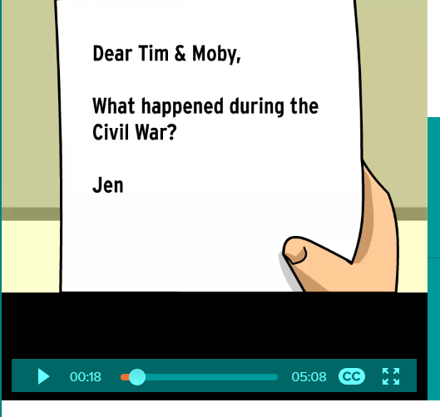
(from https://www.brainpop.com/socialstudies/ushistory/civilwar/)

Two
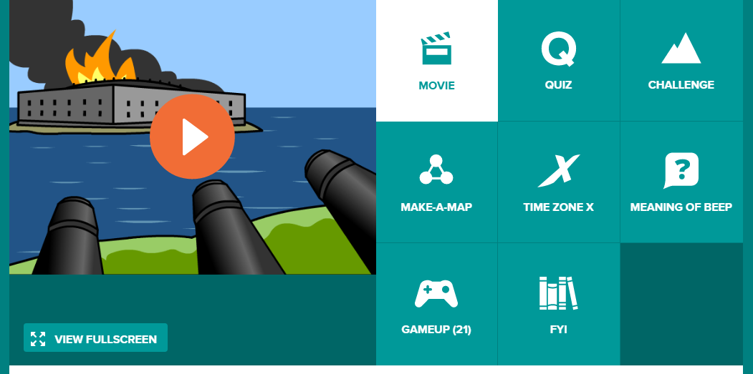
(from https://www.brainpop.com/socialstudies/ushistory/civilwar/)

Three
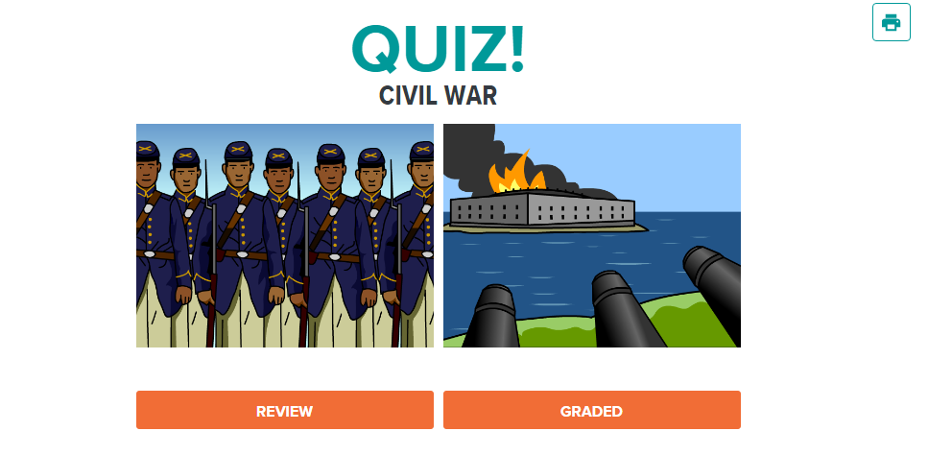
(from https://www.brainpop.com/socialstudies/ushistory/civilwar/quiz/)

Four
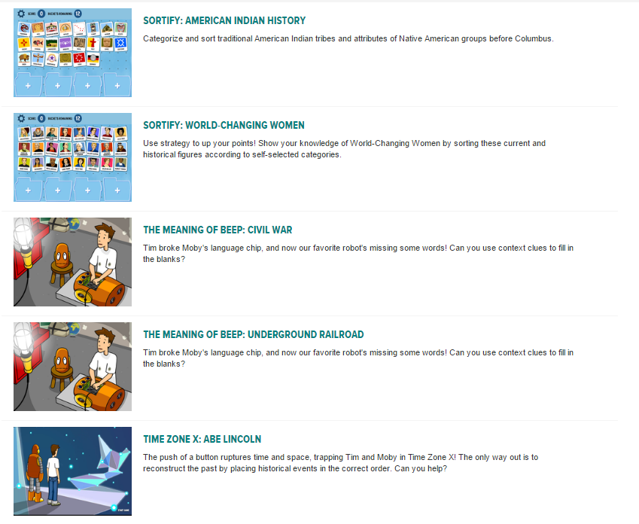
(from https://www.brainpop.com/games/game-finder/?game_keyword=Civil%20War)

Five
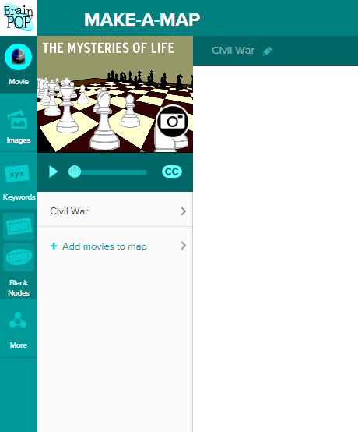
(from https://www.brainpop.com/make-a-map/?topic=/socialstudies/ushistory/civilwar/)

Six
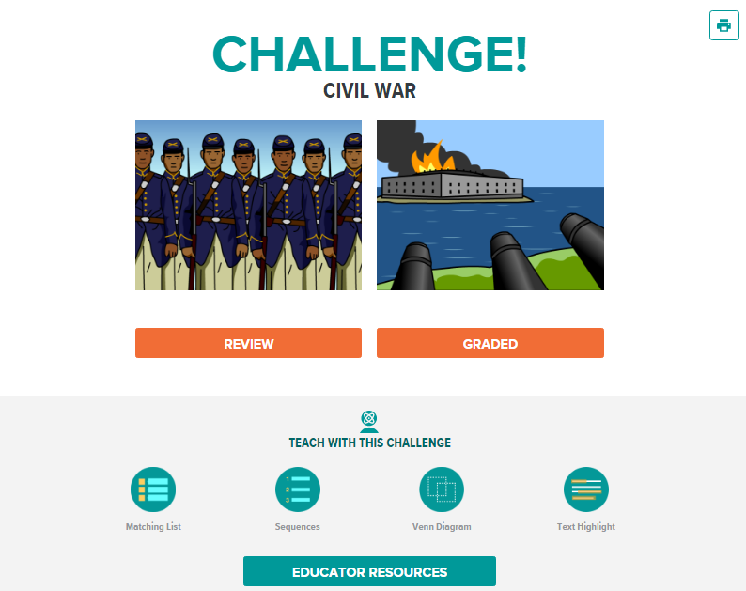
(from https://www.brainpop.com/socialstudies/ushistory/civilwar/challenge/)

